**PRODUCT REQUIREMENTS**

**Project: Amusement Park Management Website**

**Team:**

**Revision History**

|  |  |  |
| --- | --- | --- |
| **Date** | **Description** | **Author** |
| 10/09/2024 | Software Requirement |  |

**Brief Problem Statement**

Our team is funded to develop a way to help guests of an amusement park, especially those with disabilities, to be able to access the necessary resources in the park and effectively plan for their day. We engaged stakeholders and potential users and asked them what they would like the new platform to provide. It was, therefore, possible to achieve the following objectives.

-The amusements and park services should have specific descriptions of the contents and services for the rental of the amusement park rides.

-Ensure that website navigation is accessible enough for persons using screen readers and keyboard users.

* Communicate to the guests about the park's freedom and the time they are likely to wait for a ride.
* Ensure to provide information regarding the reception of people with disability and the accessibility of services to such persons.
* To make it possible to subject the visit to the specialized park to a time management plan.
* People from different backgrounds must be integrated and embraced within the system while user interfaces must be created.

This will be done by developing a web application where clients can view the current information concerning the facilities, book and utilize many concessions. It will also allow the user to input his/her preferences, get updated and even liaise with the park officials. To summarize, this will ensure that anyone visiting this platform can experience the best and quickly get any information they need, regardless of the disability level.

**Stakeholders**

**Amusement Park Management - Investor and Board of Directors:**

This project is being financed and implemented by the amusement park management, and thus, they require authorization for this purpose and funding for this accessible platform. The management team will, therefore, be engaged from the conceptualization phase of the project life cycle. There will be weekly presentations and meetings with the management and the board of directors to make them fully engaged. It will also enable additional resources as their participation needs arise.

**Amusement Park Marketing Team - Product Owner:**

The marketing department in the amusement park is the product owner. They are supposed to define what goals they want to see on the platform and explain it to the developers. The responsibilities of the product owner include: The responsibilities of the product owner include:

* Defining key features.
* Creating, reviewing, and accepting user stories and iterations.
* Complementing the overall framework and plan.
* Developing relationships with the development team.
* Prioritizing needs.
* Evaluating product progress.

**Park Visitors (End Users):**

The platform's target users are park visitors, with unique attention paid to people with disabilities. They need to be included in each phase of the development process in order to have a project that will fulfil their needs. This will be done by conducting a survey, interview, and focus group to capture the participants' views and contributions. Also, the desired number of selected users will use the platform before releasing it to ensure all necessary changes have been made

**Development Team:**

The role of the software engineering team entails directing and promoting the project's life cycle. Their responsibilities include:

* Outlining the platform's requirements.
* Setting up the platform and educating the community on various platform features.
* Testing is carried out in order to gauge its operation.
* Deconstructing the project into activities and allocating them to the members of the project.
* Staying closely abreast of the developments of tasks.
* Addressing all conditions that may be problematic, hence causing a halt in the project period.

**Users:**

The target users of the platform must meet the following criteria:

* Possess some knowledge about how the internet works and how to access information.
* Feel at ease with tools like screen readers and keyboard navigation.
* Use an updated version of a web browser.
* Visit the park daily to get the latest information on amenities, lodging, and activities.

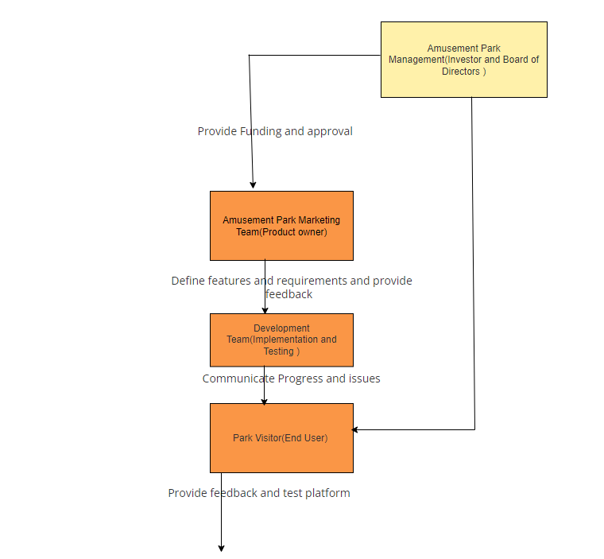

Figure 1: Shows Stakeholders Interaction

**System Requirements**

The Accessible Amusement Park Platform will be developed as a Web Application with the following technical characteristics.

* Programming Languages: JavaScript and PHP shall be used by the project.
* Front-End Technologies: The project shall use HTML and CSS for user interface development.
* Back-End Technologies: The project shall use PHP for server-side processing and as the language for data management.
* Browser Compatibility: The project shall support the current versions of major web browsers, and such requirements shall reflect the software design specification template.
* Accessibility: This platform shall ensure elements such as screen readers and navigation through the keyboard, among others.
* Responsive Design: The project shall, therefore, be compatible with various devices, including desktop, tablet, and mobile devices like smartphones.

These requirements ensure that the visage of the platform is efficient, convenient and compliant with the User’s needs.

**Feature Requirements**

|  |  |  |  |
| --- | --- | --- | --- |
| **No** | **User Story Name** | **Description** | **Release** |
| **1** | User Registration | The system shall enable users to register by inputting their details. This includes:   * Full name * Email address * Password   From the perspective of accessibility needs if necessary this will allow users to set their preferences and change their registration information. The system will also guarantee that all input data is stored safely for future logins, and updating the system will be accessible. | **R1** |
| **2** | User Login | The system shall incorporate a login function to enable the users to log into the system using their credentials. This includes:   * Email address * Password   They will be allowed to do beneficial activities such as signing in securely, resetting passwords in cases where they have forgotten, or even seeking support. It will also have password recovery options and two-factor authentication in the event of generating stronger credentials. | **R2** |
| **3** | Accessible Navigation | The system shall ensure that all the site navigation elements are laid down to be made available. This includes:   * Screen reader compatibility * The browser navigation only by input with the keyboard * They should be easily identifiable and labelled on the webpage links for accessible locations. * The coherence of the structure of the right-hand side of the menu * All links, including About, Services, Accessibility Information, Contact Us, and Help, should be easily locatable.   These features are essential for consumers with disability to work through the platform in an orderly and expeditious manner. These features will consist of buttons and links' proper and obvious naming and availability of proper and easily reachable dropdowns. | **R3** |
| **4** | Park Amenities Information | The system shall cover most of the available park's facilities, including accessibility features. This includes:   * Information on ramps, elevators and barrier-free access entrances * Information on accessible restrooms and parking area * Facilities that are available for disabled guests   This guarantees that people with different abilities and disabilities are planning to visit the place and are well-prepared and informed on accessibility. | **R4** |
| **5** | Ride Information | The system shall display real-time information about park rides, including The system shall display real-time information about park rides, including:   * Ride availability * Basically, each ride's appeal must accommodate people with disabilities. * Estimated wait times * Services for people with disabilities or people with disability special needs   It also makes it easier for visitors to plan for their visit and make some decisions on the rides they would wish to take. | **R5** |
| **6** | Booking and Reservations | The system shall allow users to schedule and make bookings and reservations on park rides and facilities. This includes:   * Selecting ride times * Indicating accessibility needs * Receiving booking confirmations * Monitoring and altering table bookings   These functionalities make the user experience more accessible regarding the booking process and planning. It will also be used to send out reservation reminders and ticket information. | **R6** |
| **7** | Time Management | The system shall offer various means to assist users in organizing their time at the premises. This includes:   * Planning their visit * Fixing of rides and events * The calendar feature is quite effective in organizing lessons. * It is an ideal way of creating reminders for specific events.   These features assist in managing time well and also improve the visitor's experience. This will help to synchronize the system with a personal calendar and deliver notifications for upcoming events. | **R7** |
| **8** | User Profile Management | The system shall provide the users with the profiles that will enable them to perform the following tasks   * Observability and change of the information stored about the person * The management of the accessibility settings and the options that accompany it * Personal account: adding/editing/deleting individuals, modifying passwords.   The users will own the profiles and will be fully qualified to change the settings whenever they want. It will also accommodate profile picture uploads and configurations for privacy settings. | **R8** |
| **9** | Communication with Park Officials | For this reason, the system shall entail interfaces allowing users to link to the park authorities. This includes:   * Inquiry forms * Support request forms * Feedback submission * Decisions to include a document or an image   These features help users call the park officials and seek their assistance. It will also consist of live chatting services and track requests and responses in the system. | **R9** |
| **10** | Feedback and Support | The system shall provide means for reporting bugs, giving feedback and asking for help. This includes:   * Some are feedback of how it was to be involved in such an activity. * Some of the recommendations focus on the questions of access. * Including extensive comments * This is mainly focused on monitoring the feedback that customers of the business are giving and the support tickets that individuals and companies are opening.   These features allow the user to provide the necessary details and ensure he or she will be provided with the correct help at the right time. The following activities demonstrate that feedback will be addressed, and support requests will be filtered and prioritized as necessary. | **R10** |
| **11** | Multilingual Support | The system shall be able to work with different users and, therefore, be made multi-lingual. This includes:   * Language selection dropdown * Interpretations of the messages that circulate through all the major media outlets across the globe * Recognition of the languages which are employed in everyday practice as equal.   These features help develop the option for users with different language proficiency levels to use the platform most effectively. The system can translate content to users’ preferences and provide assistance and support in one or several languages. | **R11** |
| **12** | Responsive Design | It shall be easy to use and capable of running on various platforms and devices. This includes:   * Compatibility with office computers, tablets, and handheld mobile phones. * Responsive layouts * Ideal examples of place for images and number of text * Adaptive content | **R12** |

### Non-Functional Requirements

**Performance**

* Homepage load time: < 2 seconds
* Primary interactions: Response time < 1 second

**Security**

* Data encryption for sensitive information
* User authentication and authorization
* Regular security updates and vulnerability assessments

**Scalability**

* Support for increasing the number of users and data volume
* Ability to handle peak usage times without degradation

**Usability**

* User-friendly interface with intuitive navigation
* Accessibility features for diverse user needs (e.g., screen reader compatibility, keyboard navigation)
* Clear instructions and feedback for user actions

**Reliability**

* System uptime: 99.9%
* Backup and recovery procedures in place

**Compatibility**

* Support for major web browsers (e.g., Chrome, Firefox, Safari, Edge)
* Mobile and tablet responsive design

**Maintainability**

* Modular codebase for more accessible updates and bug fixes
* Comprehensive documentation for system maintenance and future development

**Use case Diagram**

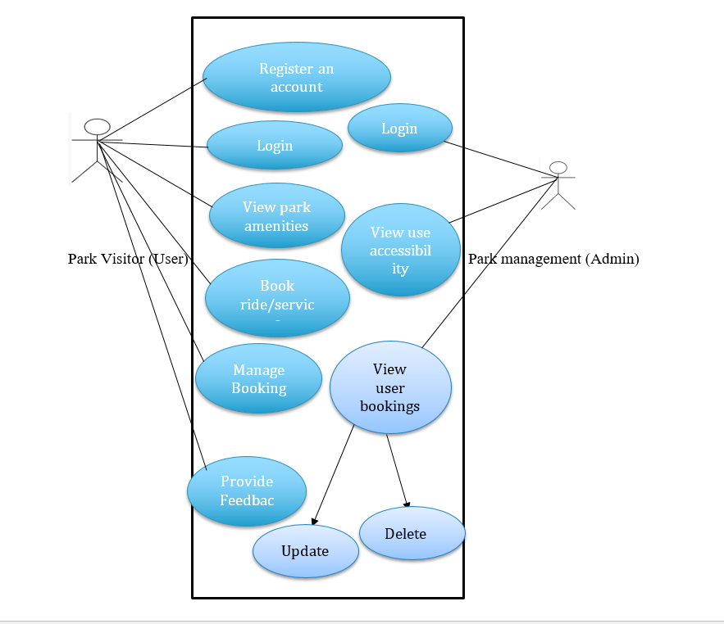

Figure 2: Use Case Diagram

**Use Case Description**

|  |  |
| --- | --- |
| **Use Case Number** | UC1 |
| **Use Case Name** | User Registration |
| **Overview** | This use case allows users to create a new account on the platform by providing their personal details and setting up a password. |
| **Actors** | Park Visitor (User) |
| **Pre-condition(s)** | User is on the registration page of the website. |
| **Scenario Flow** | **Main success Flow**   1. User navigates to the registration page. 2. User enters their full name, email address, and password. 3. User submits the registration form. 4. System validates the information and creates a new account. 5. User receives a confirmation email with a verification link. 6. User clicks on the verification link to activate their account. |
| **Alternate Flow** | -If the email address is already in use, the system returns an error message asking the user to use another email address.  -If the password entered does not meet the security requirements, the constraint message is sent, and the user is taken to the Password Options page, where a more secure password is selected. |
| Post Condition | User account is created, and the user can log in with their new credentials. |

|  |  |
| --- | --- |
| **Use Case Number** | UC2 |
| **Use Case Name** | User Login |
| **Overview** | This use case allows users to log into their account using their credentials. |
| **Actors** | Park Visitor (User) |
| **Pre-condition(s)** | User has an existing account and is on the login page. |
| **Scenario Flow** | 1. User navigates to the login page 2. User enters their email address and password. 3. User submits the login form. 4. System verifies credentials and logs the user in. 5. User is redirected to their dashboard or homepage. |
| **Alternate Flow** | If the entered email address or password is incorrect, the system will show an error message to the user and ask them to retype it.  If the user has forgotten the password, he can apply for a password reset. |
| **Post Conditions** | User account is created, and the user can log in with their new credentials. |

|  |  |
| --- | --- |
| **Use Case Number** | UC2 |
| **Use Case Name** | View Park Information |
| **Overview** | This use case allows users to browse general park details, including rides, services, and accessibility options. |
| **Actors** | Park Visitor (User) |
| **Pre-condition(s)** | User is logged into the system. |
| **Scenario Flow** | -User navigates to the park information section..  -Users get information about park rides, services, and facilities for disabled people.   1. -User information preferences can be managed according to ride type or accessibility features |
| **Alternate Flow** | If the information is not available, the system displays a message indicating that the data is currently unavailable. |
| **Post Conditions** | User has accessed and reviewed park information. |

|  |  |
| --- | --- |
| **Use Case Number** | UC4 |
| **Use Case Name** | Book Rides and Services |
| **Overview** | This use case allows users to reserve or schedule rides, services, or accommodations |
| **Actors** | Park Visitor (User) |
| **Pre-condition(s)** | User is logged into the system and has selected a ride or service. |
| **Scenario Flow** | 1. User selects a ride or service to book. 2. User chooses a time slot and indicates any accessibility needs. 3. User confirms the booking details 4. System processes the booking and sends a confirmation to the user. |
| **Alternate Flow** | If the chosen time slot is unavailable, the system prompts the user to select a different time. |
| **Post Conditions** | Booking is confirmed, and the user receives a reservation confirmation. |

|  |  |
| --- | --- |
| **Use Case Number** | UC5 |
| **Use Case Name** | Manage Bookings |
| **Overview** | This particular use case enables the clients to view their existing bookings, make changes, or cancel them. |
| **Actors** | Park Visitor (User) |
| **Pre-condition(s)** | User is logged into the system and has existing bookings. |
| **Scenario Flow** | 1. The user goes to the section containing their bookings. 2. The user sees the list of services that he/she has booked. 3. The user chooses one or many bookings to either modify or delete. 4. The user enters desired modifications or completely cancels the booking. 5. The system informs the customer of a change in the booking and shows that the booking has been updated. |
| **Alternate Flow** | The system shows an appropriate message if the booking cannot be edited or cancelled due to system limitations. |
| **Post Conditions** | Booking is updated or canceled according to the user’s request. |

|  |  |
| --- | --- |
| **Use Case Number** | UC6 |
| **Use Case Name** | Access Accessibility Information |
| **Overview** | This use case allows users to view detailed accessibility information for each ride or service. |
| **Actors** | Park Visitor (User) |
| **Pre-condition(s)** | User is logged into the system. |
| **Scenario Flow** | -User chooses a ride or a service to get information on its accessibility.  -Additional information about accessibility of the particular ride or service is provided on the system. |
| **Alternate Flow** | If there is no information on the accessibility of, for example, a particular ride or service, the system will provide a statement that the information is not available. |
| **Post Conditions** | User has accessed and reviewed accessibility information for a ride or service. |

|  |  |
| --- | --- |
| **Use Case Number** | UC7 |
| **Use Case Name** | Submit Feedback |
| **Overview** | This use case allows users to provide feedback about their experience with the platform, rides, or services. |
| **Actors** | Park Visitor (User) |
| **Pre-condition(s)** | User is logged into the system. |
| **Scenario Flow** | 1. User navigates to the feedback section. 2. User fills out a feedback form with their comments and ratings. 3. User submits the feedback form. 4. System records the feedback and confirms receipt. |
| **Alternate Flow** | If the feedback form is incomplete, the system prompts the user to complete all required fields. |
| **Post Conditions** | Feedback is submitted and recorded in the system. |

|  |  |
| --- | --- |
| **Use Case Number** | UC8 |
| **Use Case Name** | Admin Login |
| **Overview** | This use case allows park administrators to log into the system with elevated permissions. |
| **Actors** | Park Management (Admin) |
| **Pre-condition(s)** | Admin has valid credentials and is on the login page. |
| **Scenario Flow** | 1. Admin navigates to the admin login page. 2. Admin enters their username and password. 3. Admin submits the login form. 4. System verifies credentials and logs the admin in. 5. Admin is redirected to the admin dashboard. |
| **Alternate Flow** | If credentials are incorrect, the system displays an error message and prompts the admin to try again. |
| **Post Conditions** | Admin is logged in and can access admin features. |

|  |  |
| --- | --- |
| **Use Case Number** | UC9 |
| **Use Case Name** | Manage Park Information (Admin) |
| **Overview** | This use case allows administrators to add, update, or remove park details. |
| **Actors** | Park Management (Admin) |
| **Pre-condition(s)** | Admin is logged into the system. |
| **Scenario Flow** | 1. Admin navigates to the park information management section. 2. Admin selects an option to add, update, or remove park details. 3. Admin makes the necessary changes and submits them. 4. System updates the park information and confirms the changes. |
| **Alternate Flow** | If the update cannot be processed due to system constraints, the system displays a relevant message. |
| **Post Conditions** | Park information is updated or removed according to the admin’s request |

|  |  |
| --- | --- |
| **Use Case Number** | UC10 |
| **Use Case Name** | Generate Reports (Admin) |
| **Overview** | This use case allows administrators to generate usage and feedback reports for analysis. |
| **Actors** | Park Management (Admin) |
| **Pre-condition(s)** | Admin is logged into the system. |
| **Scenario Flow** | 1. Admin navigates to the report generation section. 2. Admin selects the type of report to generate (e.g., usage, feedback). 3. Admin configures report parameters and generates the report. 4. System generates the report and provides a download link or displays the report on screen. |
| **Alternate Flow** | If the report cannot be generated due to system issues, the system displays an error message. |
| **Post Conditions** | Report is generated and available for review or download. |

**Individual Contributions**

|  |  |  |
| --- | --- | --- |
| **Team Member Name** | **8-Digit Student ID** | **Task Description** |
|  |  |  |
|  |  |  |
|  |  |  |
|  |  |  |